Troubleshooting the Hozon
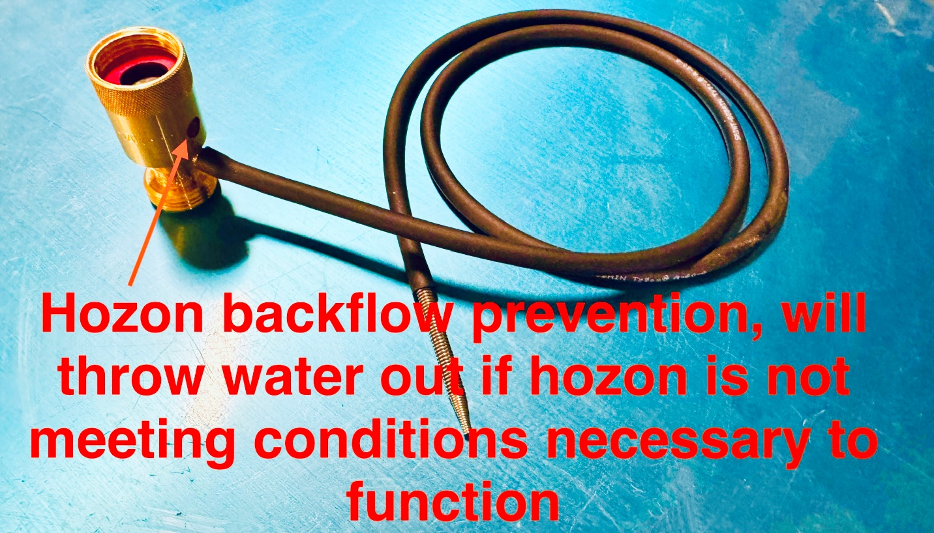
Hozon and parts
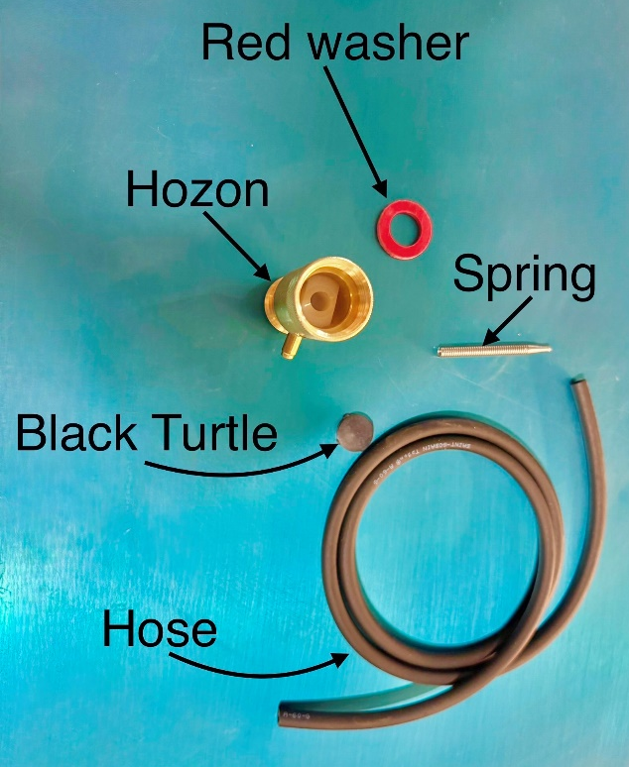
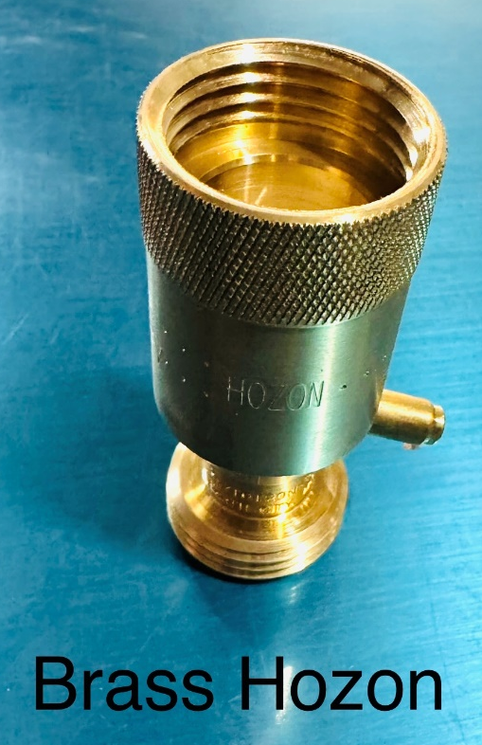
Hozon assembly
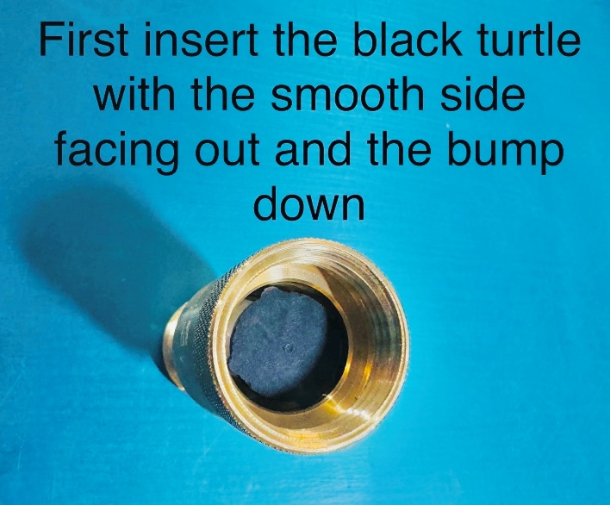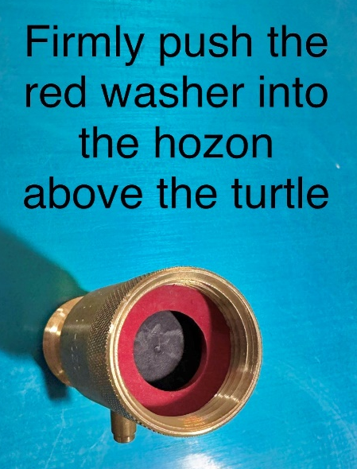
Placement of the black turtle and red washer is essential. If the turtle is not placed into the hozon with the raised side down and the flat side facing out the hozon will not siphon. The turtle goes in first then the red washer is pushed on top of it. This is part of the backflow prevent mechanism to keep the water line clean. The backflow mechanism is essential when using chemical mixtures.
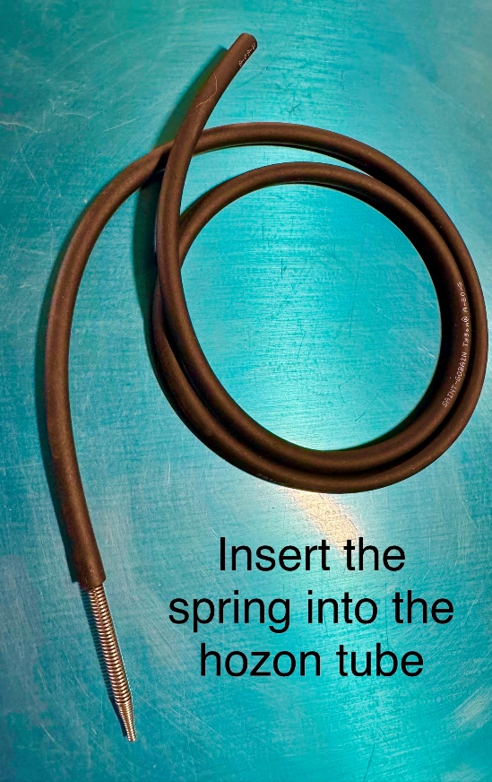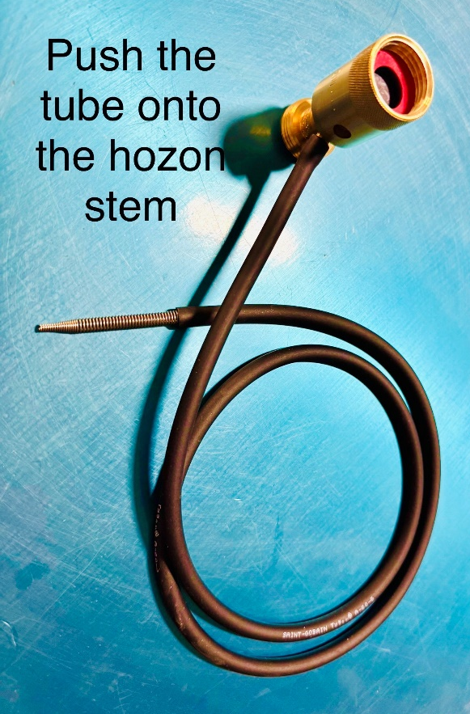
The spring is the filtration used to prevent large particles from being sucked up into the Hozon. Debris can clog the Hozon stem causing it to fail and not siphon. Debris can also build up over time causing the hozon not to function. Cleaning the Hozon brass head with the turtle, washer and tube removed can help the hozon to function again. A cleaning solution would be an overnight soaking of straight vinegar. This will still not clean out large particulates blocking the stem. The stem has a ball bearing inside essential to making the siphoning process function. This part can get clogged by a coating of from the water or solutions or mineral build up during normal operation. The soaking solution will assist only with this problem, not large particulates getting pulled into the stem and logging in place.
If the tube forms kinks it will not siphon correctly.
The backflow prevention turn on water pressure is not met. It will also not function if the wrong sprayer end is used or too small of a hose. Hoses that are expandable are not compatible with this device.

